**One Page Checkout**

* In Magento admin panel we have a built in one step checkout option
* Magento admin panel->store->configuration->sales->checkout
* We have an option to enable one step checkout

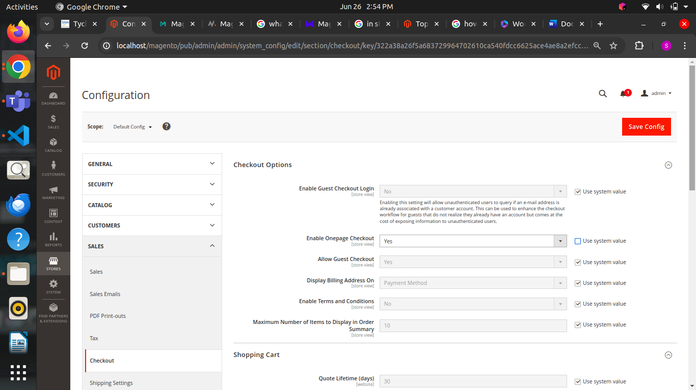

|  |  |  |
| --- | --- | --- |
| Feature / Aspect | Built-in One Step Checkout (Magento) | Third-Party One Step Checkout Extensions |
| Cost | Included in Magento, no additional cost | Typically requires purchase or subscription |
| Customization | Basic layout and field customization options | Extensive customization options for design and features |
| Performance Optimization | Standard performance based on Magento’s capabilities | Optimized for speed with advanced caching and code |
| Integration | Native integration with Magento’s core | May integrate with third-party services, payment gateways |
| Support & Updates | Support included with Magento updates | Dedicated support, frequent updates from third-party devs |
| Compatibility | |  | | --- | |  |  |  | | --- | | Ensures compatibility with Magento versions and extensions | | Compatibility checks with newer Magento versions |
| User Experience | Simple and functional, may lack advanced UX enhancements | Enhanced UX with features like guest checkout improvements |
| Additional Features | Limited to Magento’s built-in capabilities | Offers additional features like delivery date pickers, etc |
| Ease of Setup | |  | | --- | |  |  |  | | --- | | Easy to enable within Magento admin panel | | Requires installation/configuration from third-party devs |
| Features | Basic consolidation of checkout steps | Additional features like AJAX loading, custom fields, etc. |

* **Magento's Built-in One Step Checkout:**

**Advantages:**

* **Cost-effective**: Included in Magento without additional purchase.
* **Native Integration**: Seamlessly integrates with Magento’s core functionalities.
* **Compatibility**: Ensures compatibility with other Magento features and updates.
* **Support**: Support is included with Magento updates.
* **Ease of Setup**: Easy to enable and configure within Magento admin panel.

**Disadvantages:**

* **Limited Features**: Offers basic features compared to some third-party extensions.
* **Customization**: Limited customization options for design and advanced functionality.
* **User Experience**: May lack advanced UX enhancements available in third-party extensions.
* **Performance**: Standard performance based on Magento’s capabilities, potentially less optimized than third-party solutions.
* **Updates**: Dependent on Magento’s update schedule; may not receive as frequent updates or new features as third-party extensions.
* **Third-Party One Step Checkout Extensions:**

**Advantages:**

* **Advanced Features**: Offers additional features like AJAX loading, custom fields, delivery date pickers, etc.
* **Enhanced Customization**: Extensive options for design, layout, and user interface customization.
* **Performance Optimization**: Often optimized for speed with advanced caching and code.
* **Support & Updates**: Dedicated support, frequent updates, and compatibility checks with newer Magento versions.
* **Integration Options**: May integrate with third-party services, payment gateways, and analytics tools.

**Disadvantages:**

* **Cost**: Typically involves additional costs for purchase or subscription.
* **Dependency**: Relies on third-party developers for updates and support.
* **Compatibility Risks**: Potential compatibility issues with other Magento extensions or future updates.
* **Complexity**: Installation and configuration may require more technical expertise.
* **Vendor Reliability**: Relies on the reliability and longevity of the third-party extension provider.

**Third party extension for one step checkout**

* We can simply add all the details like

* Shipping Address

* Shipping Methods

* Delivery

* Payment Methods

We can easily access all the details in one page it is the main use of this extension

